DOI: https://doi.org/10.48009/1_iis_2021_xx-xx (Note: The DOI will be completed by the editor)

The title goes here: 16 points & bold Left Justified

FirstName LastName, Affiliation, myemail@domain.edu
FirstName LastName, Affiliation, myemail@domain.edu
FirstName LastName, Affiliation, myemail@domain.edu

(Note) Names: 11 points & bold, Affiliation & email addresses: 11 points italicize

Abstract

The abstract will go in this box (Times New Roman 11, justified text). Please do not change the margins. The abstract shall not be divided into separate paragraphs.

Keywords: ethics, information technology, undergraduate students

Notes
Headings: 12 points & Bold, no Cap (Sentence case), Centered

Introduction

Font Type & Size: Times New Roman 11, justified text

First-level subheading(s) 11 points & Bold, left-justified

Font Type & Size: Times New Roman 11, justified text

Second-level subheading(s) 11 points & Bold, Italicized, left-justified

Font Type & Size: Times New Roman 11, justified text

Methodology

Font Type & Size: Times New Roman 11, justified text

Results
Font Type & Size: Times New Roman 11, justified text

Table 1: Means and Standard Deviations for Gender
 | N | Mean | Std. Deviation | Std. Error
Female | 81 | 5.2222 | 1.31992 | .14666
Male | 83 | 5.2319 | 1.16267 | .12762
Total | 164 | 5.2271 | 1.23901 | .09675

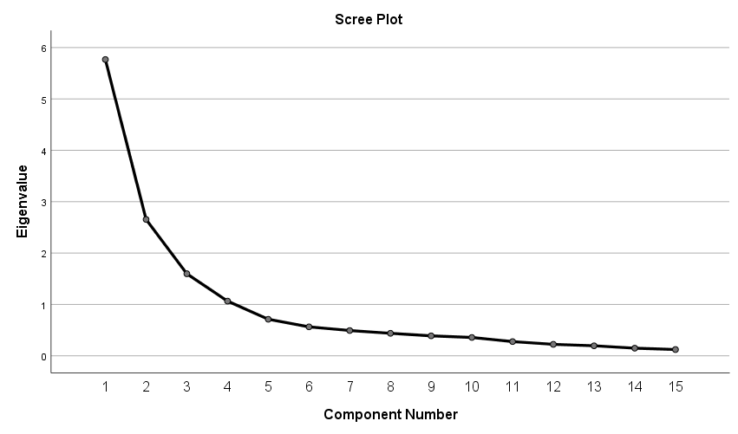
Figure 1: Scree Plot Test

Discussion

Font Type & Size: Times New Roman 11, justified text

References

Font Type & Size: Times New Roman 11, indent/hanging .05 inch. References must be in APA Style and listed alphabetically - use the following guide https://writingcenter.uagc.edu/format-your-reference-list

